10TH ANNUAL KY NATIONAL GUARD
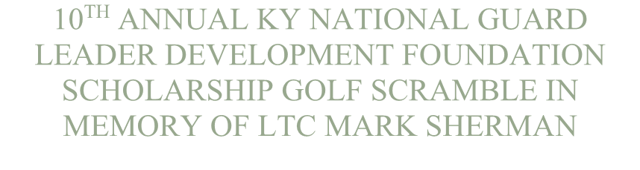
LEADER DEVELOPMENT FOUNDATION
SCHOLARSHIP GOLF SCRAMBLE IN
MEMORY OF LTC MARK SHERMAN

FRIDAY – 30 SEPTEMBER 2022 ENTRY FEE: $55.00 PERSON
SHAWNEE GOLF COURSE REGISTRATION: 0715-0815 460 NORTHWESTERN PKWY SHOTGUN START: 0830 LOUISVILLE, KY

LUNCH TO IMMEDIATELY FOLLOW TOURNAMENT

Your entry fee includes green fee, cart, lunch, and door prizes. All proceeds, after expenses, will be presented as scholarships in Mark Sherman’s name through the KY National Guard Leader Development Foundation.

--------------------------------------ENTRY FORM------------------------------------------------

TEAM CAPTAIN: _______________________________PHONE #:________________

ADDRESS: ______________________________________________________________

CITY: ____________________________________ STATE: _______ ZIP: __________

PLAYER 2: _____________________________________________________________

PLAYER 3: _____________________________________________________________

PLAYER 4: _____________________________________________________________

PLAYING WILL BE LIMITED TO THE FIRST 100 PLAYERS

(Get yourself or your team signed up early to ensure a spot)

Mulligans will be available for purchase when you sign in on tournament day.

POINT OF CONTACT: Bryan McCoy (502)229-1575

ENTRY FORMS CAN BE E-MAILED TO: bmccoy143@gmail.com

Payment can be made to Bryan McCoy in person or mailed to:

Bryan McCoy
910 Black Oak Drive
Lawrenceburg, KY 40342

MAKE CHECKS PAYABLE TO: KNGLDF

