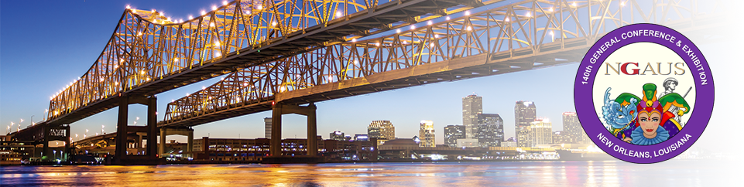

Greetings:

The 140TH General NGAUS Conference will be in New Orleans, LA. on August 24-27, 2018. This year we will be in the Ernest N. Morial Convention Center, located at 900 Convention Blvd. Make plans to join us in New Orleans for updates from the guest speakers and a great time with a Mardi Gras flavor.

Kentucky's delegates will be staying at the Sheraton downtown at 500 Canal Street. Each individual will register for the NGAUS Conference through our State Association and pay a $100.00 room deposit along with the basic registration of $180.00 per person and any additional activities not covered.

REGISTRATION FORM IS ATTACHED

Please contact Jim Simms at NGAKY at 502-564-7500 for any questions.

Please visit our website at https://ngaky.org/conferences/ or NGAUS at www.ngaus.org for more information.

I have a limited number of rooms, for those planning to attend please register early!

Deadline for registration with Hotel Reservation :14 August 2018
Deadline for registration for Conference only :17 August 2018

Registration per guest $180.00
Hotel Deposit $100.00 will be credited upon check out
Hotel Rate: $114.00 plus tax per

